**Lab report no 12**



**Fall 2021**

# Computer Architecture and organization Lab

**Submitted By**

**Names Registration No**

# Wajid ulla 19pwcse1759

Section: **A**

**Date**:24,2,21

**Submitted to: Dr Amaad khalil**

Department of Computer Systems Engineering

University of Engineering and Technology, Peshawar

**Task no 1 : -**

**Mux2x1assign: -**

module mux2x1assign(A,B,set,f);

input A,B,set;

output f;

assign f = set? B:A;

endmodule

**Stim: -**

module stim6();

reg A,B,set;

wire f;

mux2x1assign trr(A,B,set,f);

initial

begin

$display ("A B set f");

A=0;B=0; set=0;

#10 $display("%b %b %b %b",A,B,set,f);

A=0;B=0; set=1;

#10 $display("%b %b %b %b",A,B,set,f);

A=0;B=1; set=0;

#10 $display("%b %b %b %b",A,B,set,f);

A=0;B=1; set=1;

#10 $display("%b %b %b %b",A,B,set,f);

A=1;B=0; set=0;

#10 $display("%b %b %b %b",A,B,set,f);

A=0;B=1; set=1;

#10 $display("%b %b %b %b",A,B,set,f);

A=0;B=0; set=1;

#10 $display("%b %b %b %b",A,B,set,f);

A=1;B=1; set=1;

#10 $display("%b %b %b %b",A,B,set,f);

end

endmodule

**Design Circuit: -**

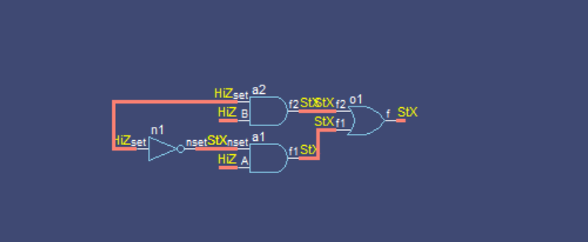

**Task no 2 (4x1mux): -**

**Code: -**

**Mux4x1assign module: -**

module mux4x1assign(A,B,C,D,set0,set1,f);

input A,B,C,D,set0,set1;

output f;

assign f = set1?(set0?D:C):(set0? B:A);

endmodule

**Stim module (using monitor): -**

module stim7();

reg A,B,C,D,set0,set1;

wire f;

mux4x1assign tr(A,B,C,D,set0,set1,f);

initial

begin

$display ("A B C D Set0 set1");

#10 A=0;B=0; C=0; D=0; set0=0; set1=0;

#10 A=0;B=0; C=0; D=0; set0=0; set1=1;

#10 A=0;B=0; C=0; D=0; set0=1; set1=0;

#10 A=0;B=0; C=0; D=1; set0=1; set1=0;

#10 A=0;B=0; C=1; D=0; set0=1; set1=0;

#10 A=0;B=1; C=0; D=0; set0=1; set1=0;

#10 A=1;B=0; C=0; D=0; set0=1; set1=0;

#10 A=0;B=0; C=0; D=0; set0=0; set1=0;

end

initial

begin

#2 $monitor("A=%b B=%b C=%b D=%b set0=%b set1=%b f=%b",A,B,C,D,set0,set1,f);

end

endmodule

**Design Circuit: -**

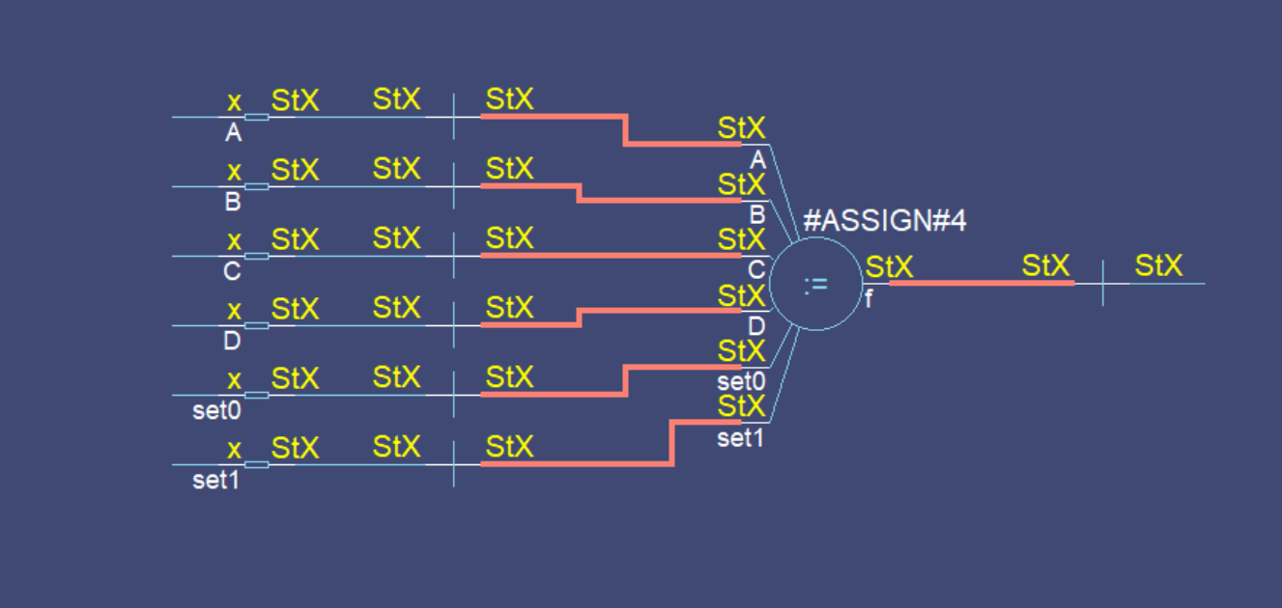

**Task no 3 (Half adder with dataflow method): -**

**Code: -**

module halfadderassign(A,B,f1,f2);

input A,B;

output f1,f2;

assign f1= A & B;

assign f2= A & ~B | ~A & B;

endmodule

**Task no 4 (2x4 decoder with dataflow method): -**

**Code: -**

module decoder2x4(A,B,F1,F2,F3,F4);

input A,B;

output F1,F2,F3,F4;

assign F1 = ~A & ~B;

assign F2 = ~A & B;

assign F3 = A & ~B;

assign F4 = A & B;

endmodule

**Stim 2x4 decoder module: -**

module stimdecoderwithovrflow();

reg A,B;

wire F1,F2,F3,F4;

decoder2x4 tr(A,B,F1,F2,F3,F4);

initial

begin

$display ("A B F1 F2 F3 F4");

A=0; B=0;

#10 $display("%b %b %b %b %b %b",A,B,F1,F2,F3,F4);

A=0; B=1;

#10 $display("%b %b %b %b %b %b", A,B,F1,F2,F3,F4);

A=1; B=0;

#10 $display("%b %b %b %b %b %b", A,B,F1,F2,F3,F4);

A=1; B=1;

#10 $display("%b %b %b %b %b %b", A,B,F1,F2,F3,F4);

end

endmodule

**Design Circuit: -**

